**ASSIGNMENT 3**

**NAME : - SUSHANT KUMAR SINGH**

**EMAIL :-** [**ssushant886@gmail.com**](mailto:ssushant886@gmail.com)

**Tasks 1: Database Design:**

1. **Create the database named "HMBank"**

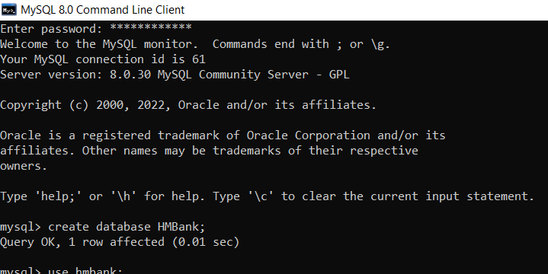

1. **Define the schema for the Customers, Accounts, and Transactions tables based on the provided schema.**
2. **CUSTOMERS SCHEMA**

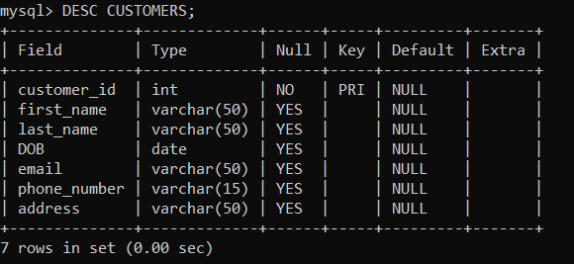

1. **ACCOUNTS SCHEMA**

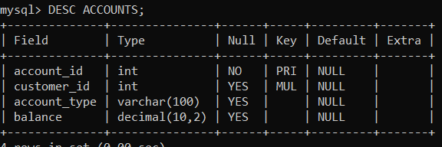

1. **TRANSACTIONS SCHEMA**

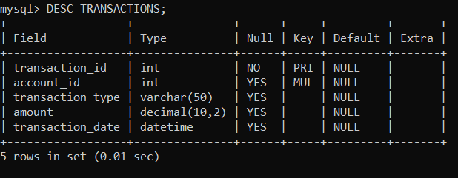

**4. Create an ERD (Entity Relationship Diagram) for the database.**

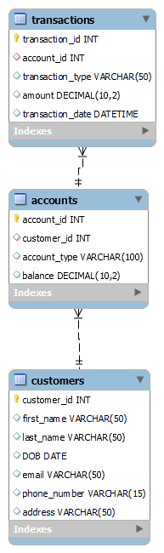

**6. Write SQL scripts to create the mentioned tables with appropriate data types, constraints, and relationships. • Customers • Accounts • Transactions**

1. **CUSTOMES**

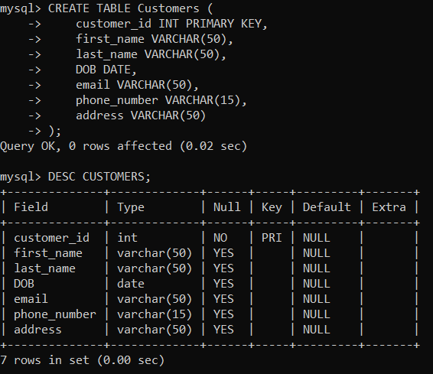

**2) ACCOUNTS**

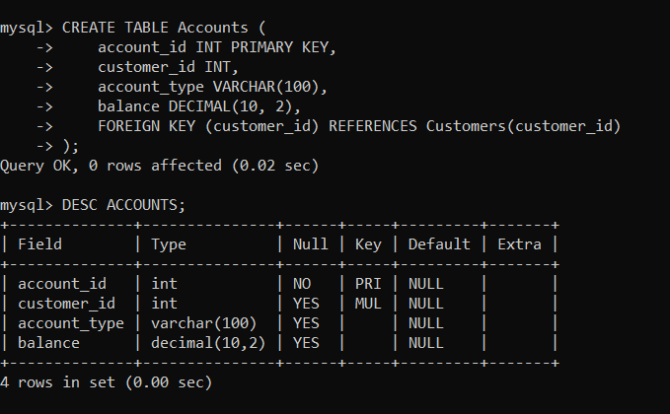

**3) TRANSACTIONS**

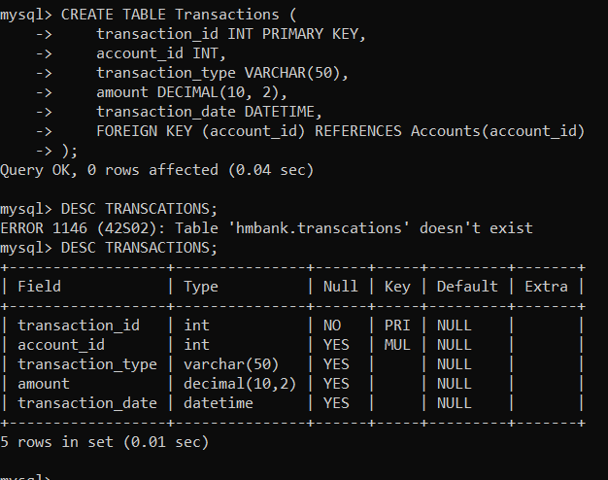

**Tasks 2: Select, Where, Between, AND, LIKE:**

1. **Insert at least 10 sample records into each of the following tables**

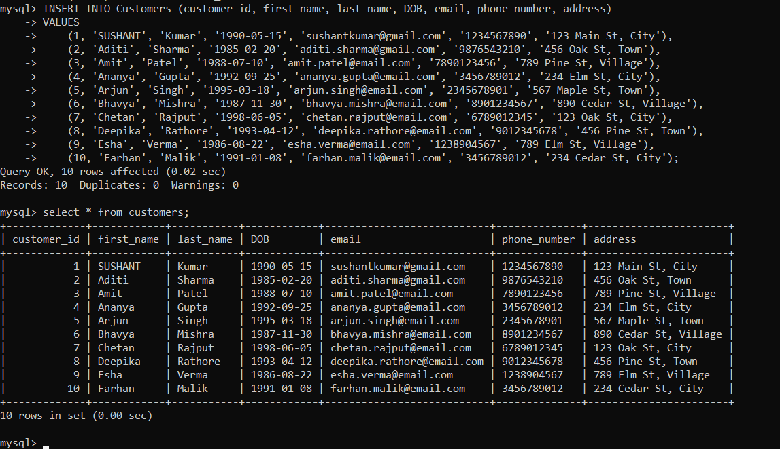**. • Customers • Accounts • Transactions**

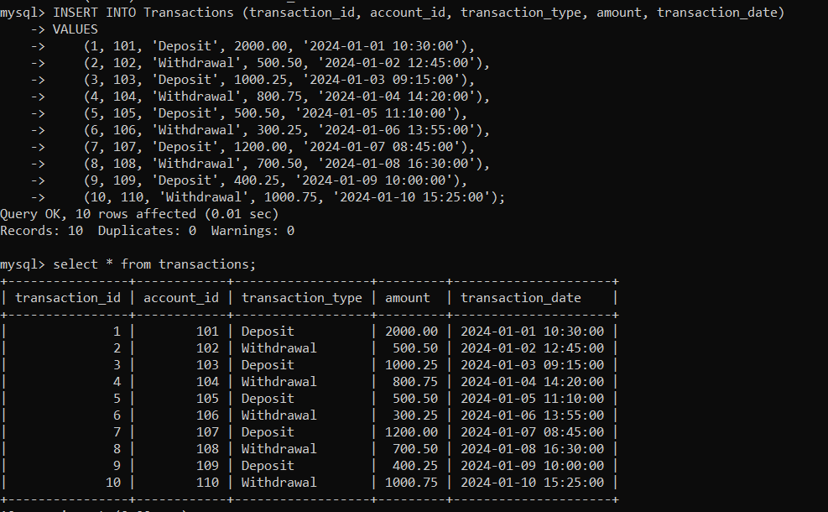

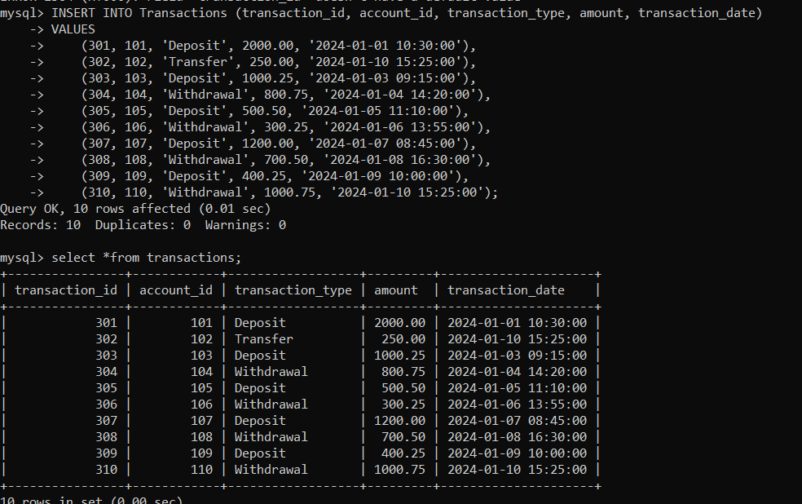

**2. Write SQL queries for the following tasks:**

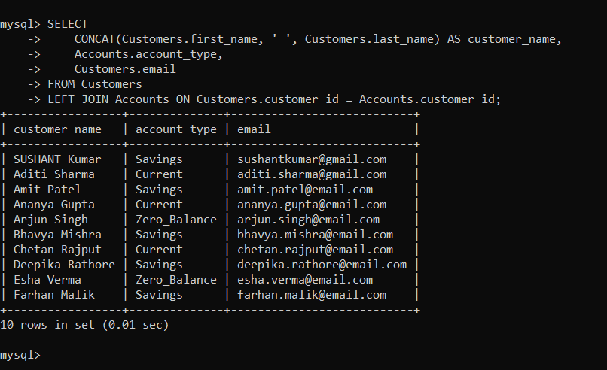 **1. Write a SQL query to retrieve the name, account type and email of all customers.**

**2. Write a SQL query to list all transaction corresponding customer.**

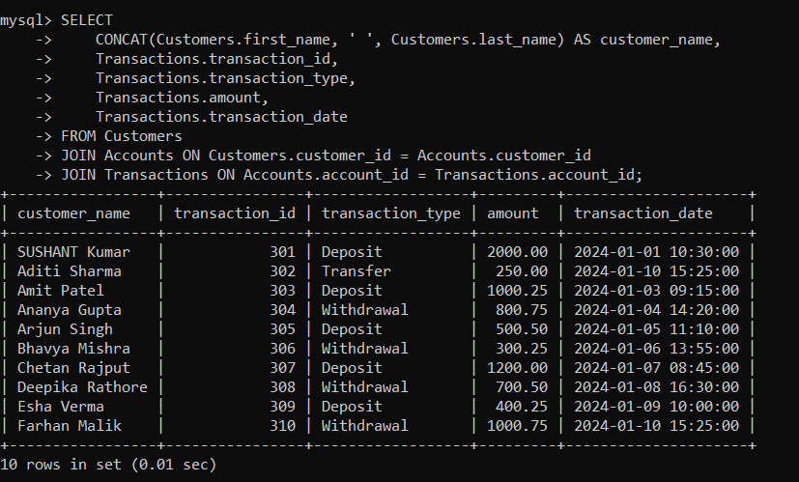

**3. Write a SQL query to increase the balance of a specific account by a certain amount.**

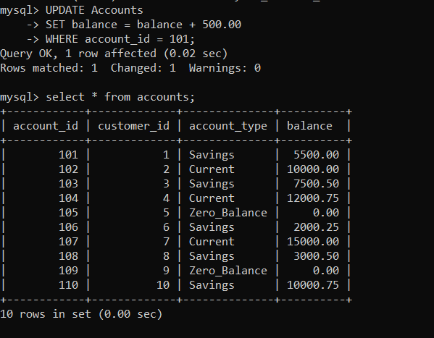

**4. Write a SQL query to Combine first and last names of customers as a full_name.**

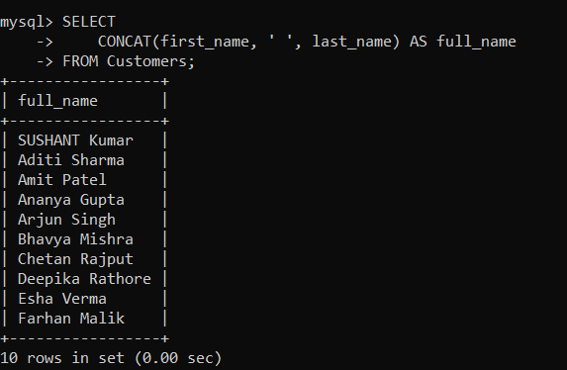

**5. Write a SQL query to remove accounts with a balance of zero where the account type is savings.**

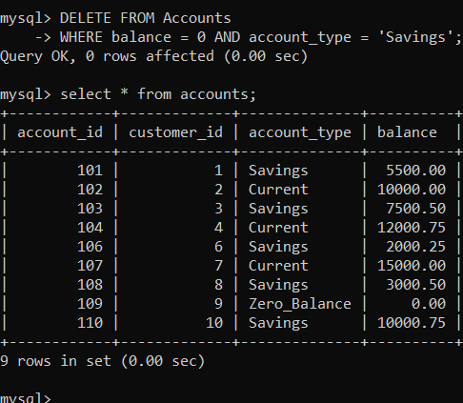

**6. Write a SQL query to Find customers living in a specific city.**

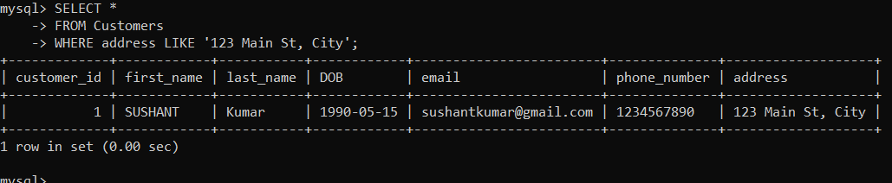

**7. Write a SQL query to Get the account balance for a specific account.**

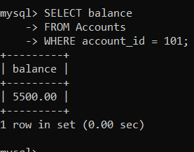

**8. Write a SQL query to List all current accounts with a balance greater than $1,000.**

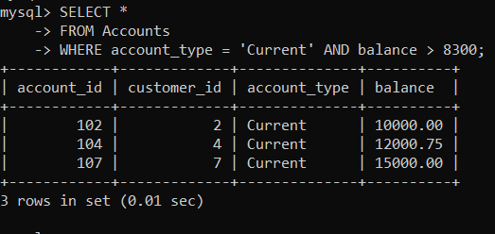

**9) Write a SQL query to Retrieve all transactions for a specific account.**

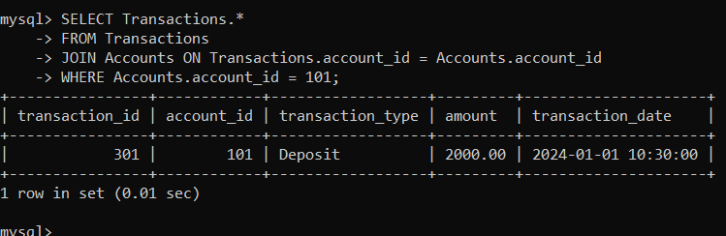

**10. Write a SQL query to Calculate the interest accrued on savings accounts based on a given interest rate.**

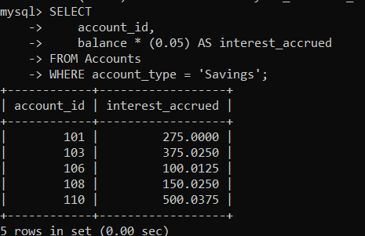

**11. Write a SQL query to Identify accounts where the balance is less than a specified overdraft limit.**

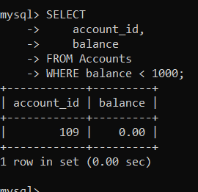

**12. Write a SQL query to Find customers not living in a specific city**

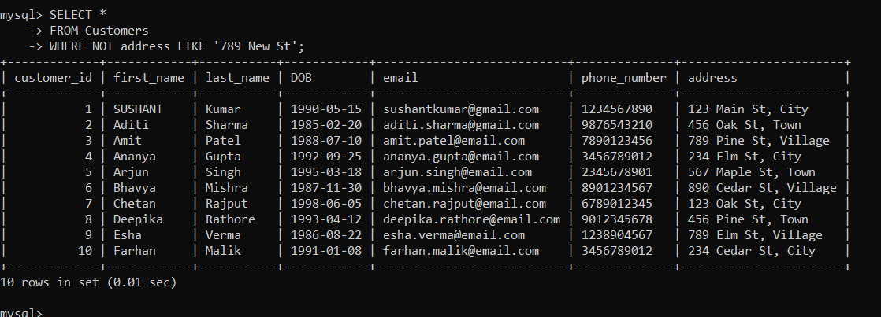

**Tasks 3: Aggregate functions, Having, Order By, GroupBy and Joins:**

**1. Write a SQL query to Find the average account balance for all customers.**

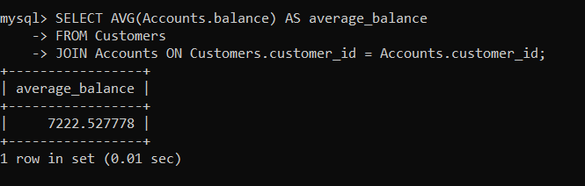

**2. Write a SQL query to Retrieve the top 10 highest account balances.**

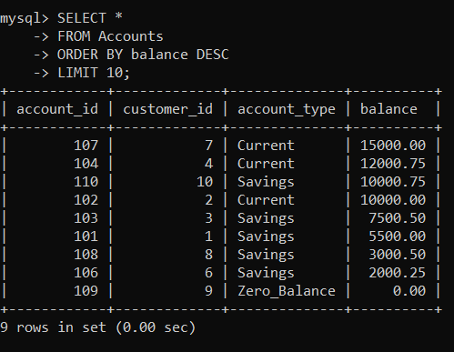

**3. Write a SQL query to list all transaction corresponding customer.**

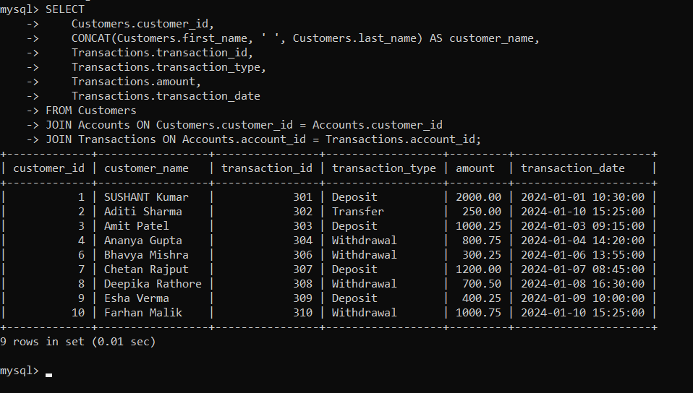

**4. Write a SQL query to Find the Oldest and Newest Customers.**

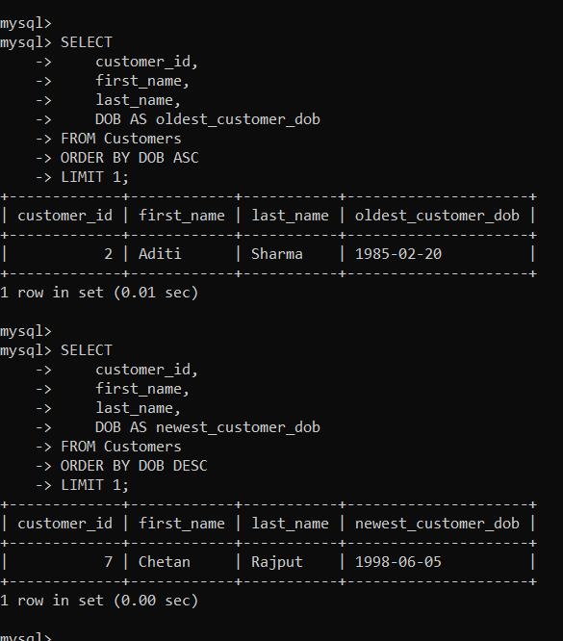

**5. Write a SQL query to Retrieve transaction details along with the account type.**

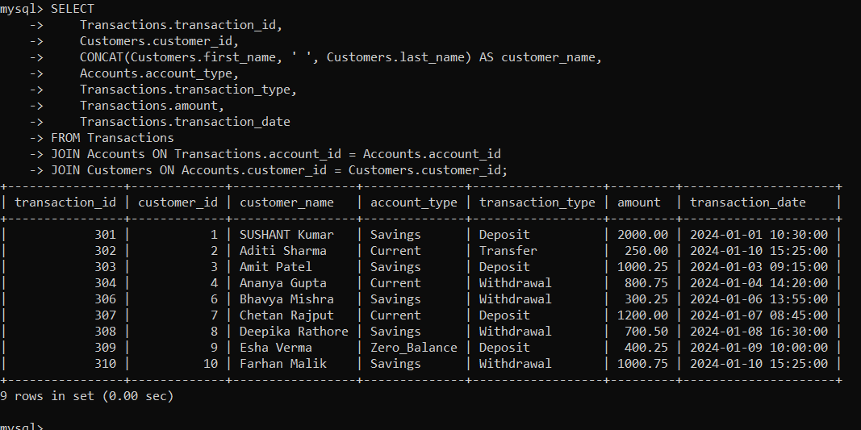

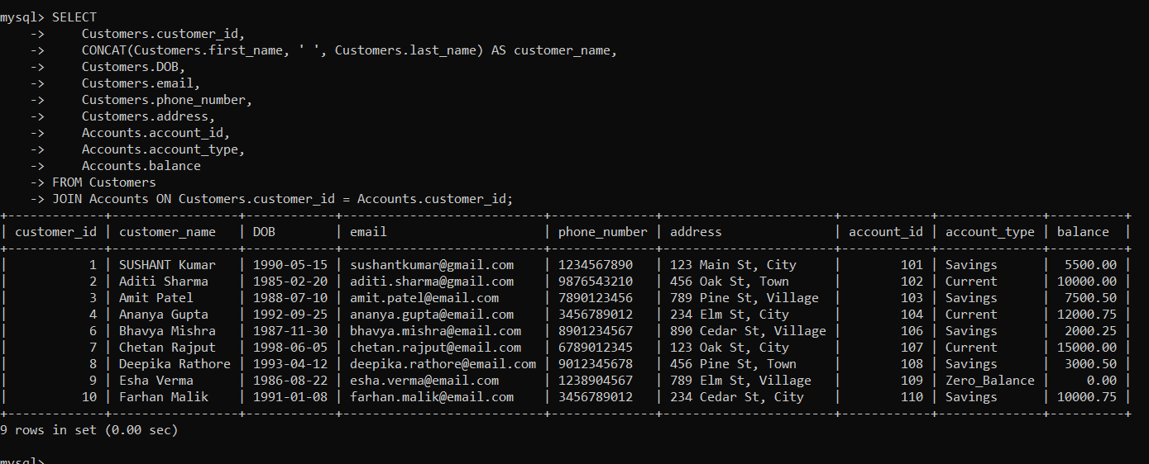**6. Write a SQL query to Get a list of customers along with their account details.**

**7. Write a SQL query to Retrieve transaction details along with customer information for a specific**

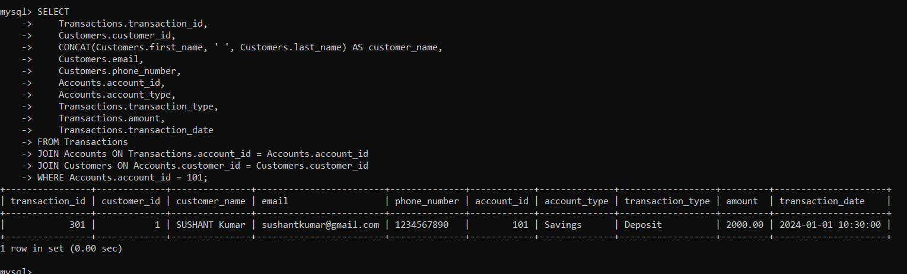**account.**

**8. Write a SQL query to Identify customers who have more than one account.**

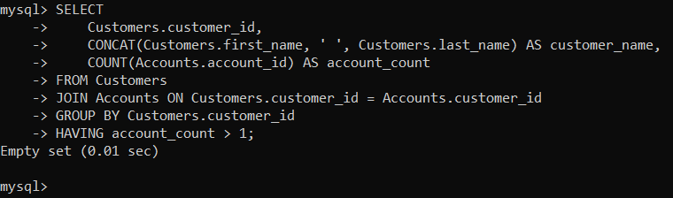

**9. Write a SQL query to Calculate the difference in transaction amounts between deposits and withdrawals.**

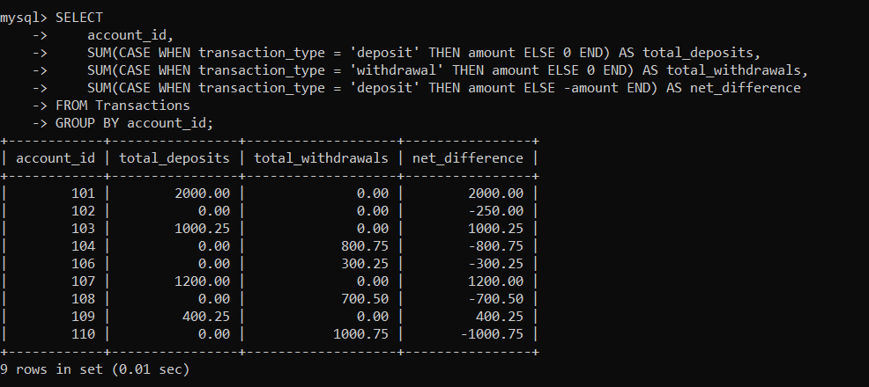

**10. Write a SQL query to Calculate the average daily balance for each account over a specified period.**

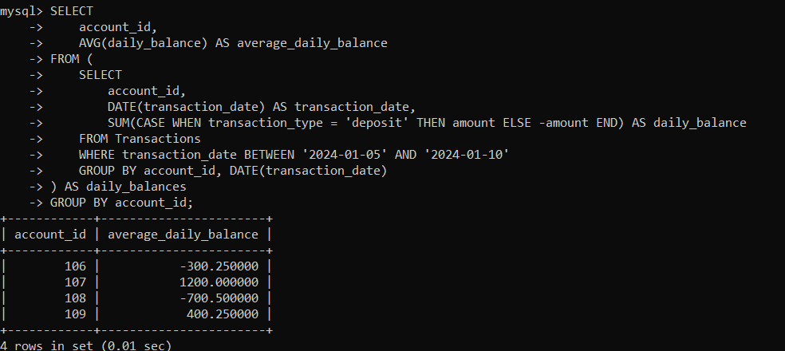

**11. Calculate the total balance for each account type.**

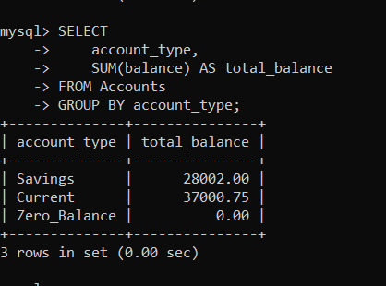

**12. Identify accounts with the highest number of transactions order by descending order.**

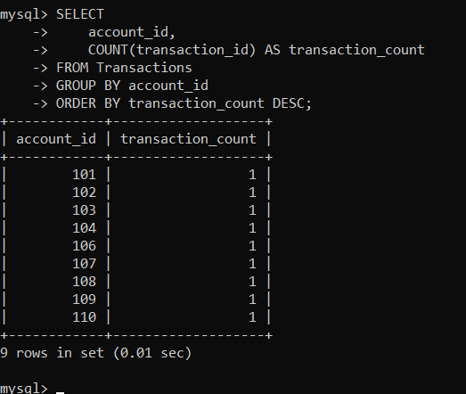

**13. List customers with high aggregate account balances, along with their account types.**

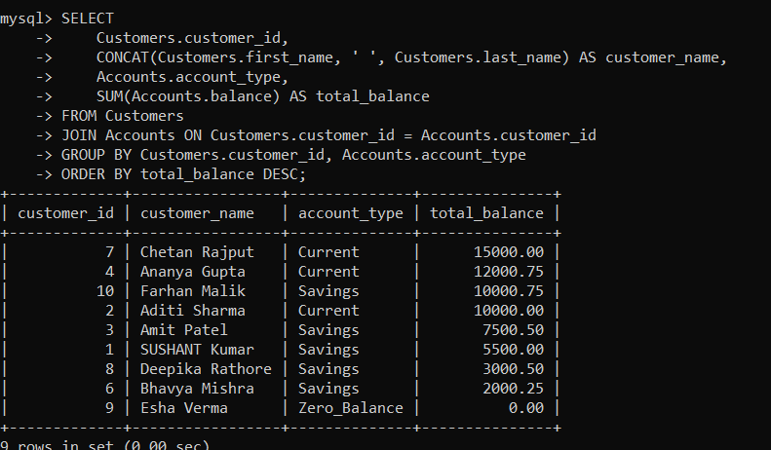

**14. Identify and list duplicate transactions based on transaction amount, date, and account.**

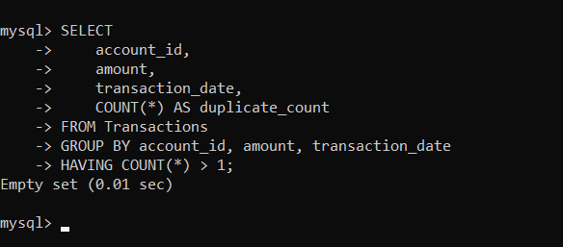

**Tasks 4: Subquery and its type:**

**1. Retrieve the customer(s) with the highest account balance.**

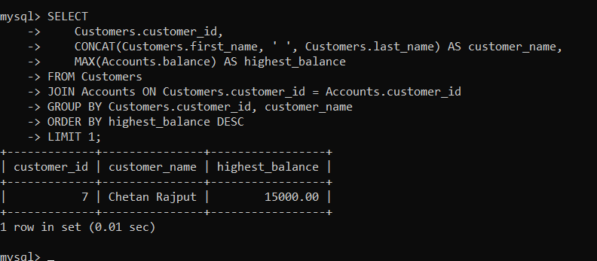

**2. Calculate the average account balance for customers who have more than one account.**

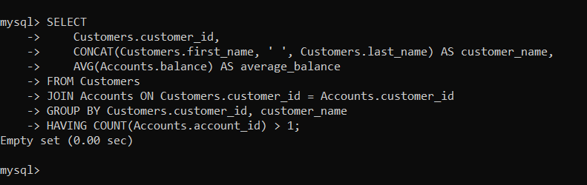

**3. Retrieve accounts with transactions whose amounts exceed the average transaction amount.**

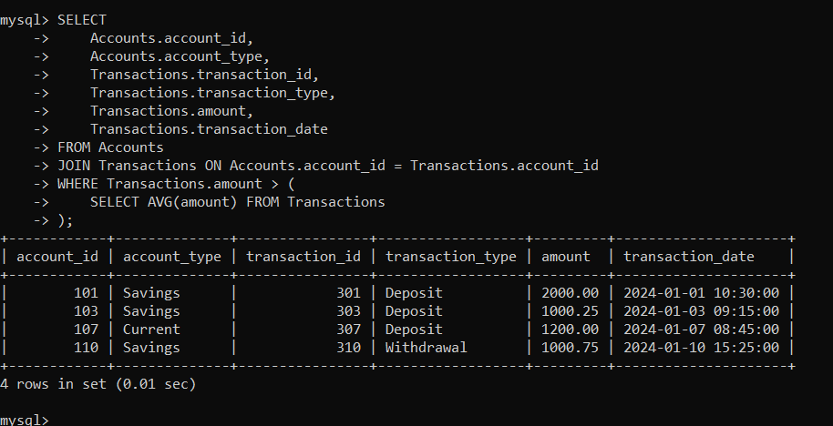

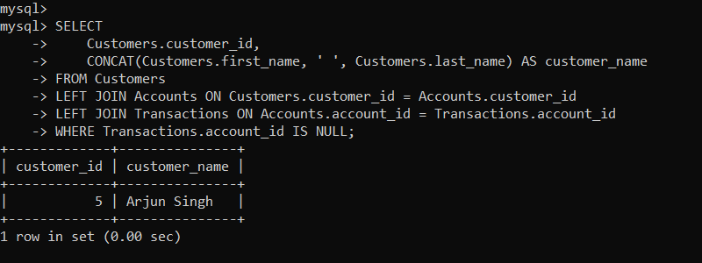 **4. Identify customers who have no recorded transactions.**

**5. Calculate the total balance of accounts with no recorded transactions.**

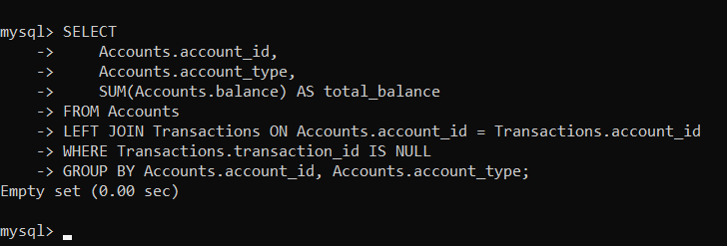

**6. Retrieve transactions for accounts with the lowest balance.**

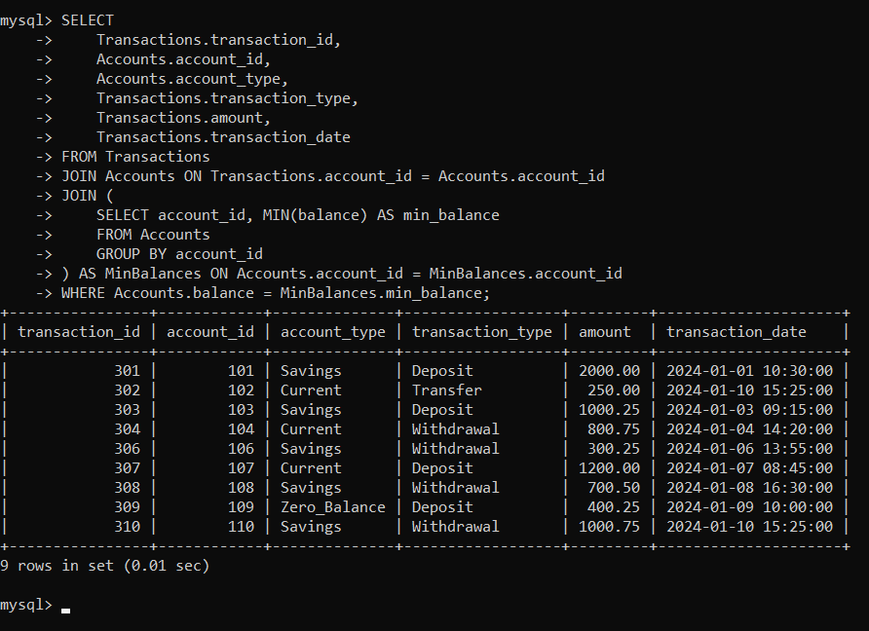

**7. Identify customers who have accounts of multiple types.**

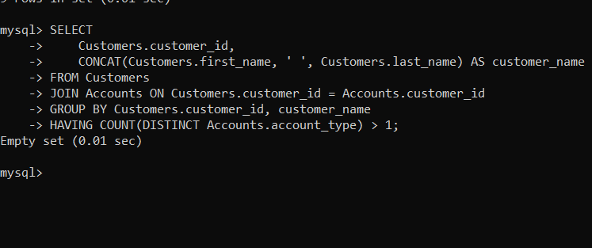

**8. Calculate the percentage of each account type out of the total number of accounts.**

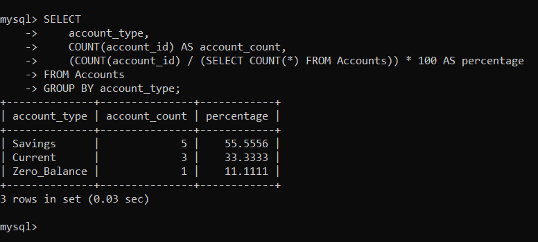

**9. Retrieve all transactions for a customer with a given customer_id.**

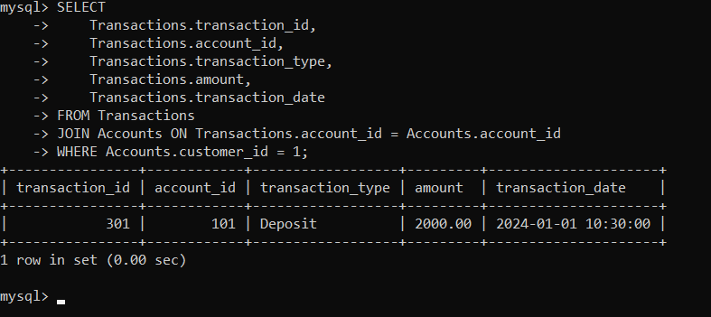

**10. Calculate the total balance for each account type, including a subquery within the SELECT clause.**

